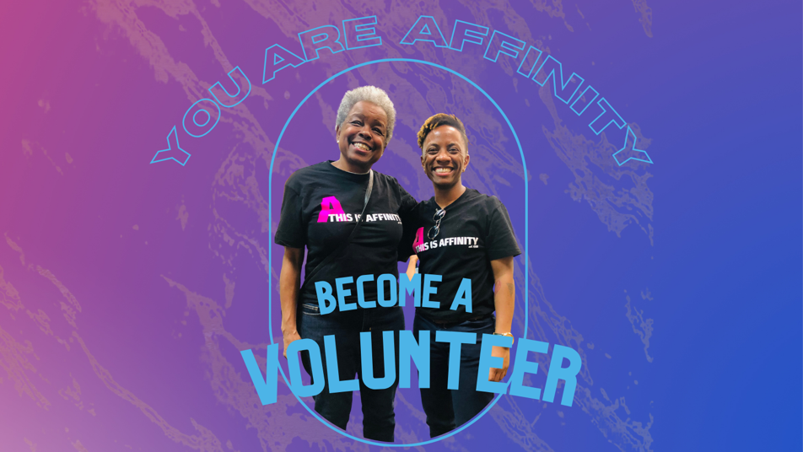

We envision a world where all Black LGBTQ+ people can be free - and volunteers help make it happen. Our volunteers are dedicated to dismantling racism, sexism, and transphobia. Together we build connections across generations, promote social justice, and celebrate Black LGBTQ lives to spread change.

To Volunteer with Affinity, please complete the following:
1) Online Volunteer Application
Please fill in as much information as you can in the online application below, as it helps us match you with the most appropriate opportunities. If you do not feel comfortable answering a required question use "N/A".
If you prefer to not apply online, please download and complete this Volunteer Application and email to info@affinity95.org or mail it to Affinity Community Services, 2850 S Wabash Ave, Suite 108, Chicago, IL, 60616.
2) Attend a New Volunteer Orientation
We hold volunteer orientations about once a month. Join us to learn more about our mission as an organization, our current volunteer opportunities, and about how staff and volunteers work together. Attending a volunteer orientation is a requirement for anyone who wants to volunteer. Visit our Events page to view and register for upcoming volunteer orientations (if none are currently listed, check back again soon).
Questions? Contact our Executive Director, Latonya Maley at Latonya.M@affinity95.org.
We look forward to building with you!

Contact Information

Legal Name *:
Prefix First Name Last Name Suffix
Name*:
If your name is different than your legal name, please list it here.
Email*:
Address*:
Phone*:

Personal Information
The following questions help Affinity Community Services track various demographic data; this information will not be used for screening and placement.

What is your date of birth?*:
 | ( mm / dd/ yyyy )
Pronouns:  What pronouns do you like people to use when referring to you?  (Check all that apply.) | __ She/ Her ___ They/ Them __He / Him  ___ None __Other: _________________________
Gender Identity  Please select the term that most fits with how you identify in terms of your gender. (Select all that apply.) | ___ Transgender Woman. __ Cisgender Woman  __ Non-Binary / Gender Fluid __ Transgender Man  __ Cisgender Man __ Other: ______________________
Personal Information (continued)
The following questions help Affinity Community Services track various demographic data; this information will not be used for screening and placement.

Sexual Identity:  Please select the term that most fits with how you identify in terms of your sexual identity. (Select all that apply.) | __Lesbian __ Bisexual __ Queer __ Gay  __ Heterosexual __ Other: ________________
Accessibility Needs:
Do you have physical, emotional, mental needs that we can assist with accommodating with your volunteer experience?

Background

Are you enrolled in school? | __ Yes __No
Education  What is the highest level of education you've completed? (Select one) | ___Grade School ___ High School ___ College  ___Graduate School ___ Technical / Vocational School
Occupation:

Previous Volunteer Experience:
Describe previous volunteer roles and duties.

Volunteer Interests

Why are you interested in volunteering with Affinity? *
Are you volunteering to fulfill required community service hours? | __Yes __No
Please list any skills, interests, or trainings that you offer that might benefit Affinity.

Skill / Training/ Interest | Proficiency Level  __ Skilled __Can Teach __Amateur  __ Skilled __Can Teach __Amateur  __ Skilled __Can Teach __Amateur  __ Skilled __Can Teach __Amateur  __ Skilled __Can Teach __Amateur
What activities are you interested in supporting? (select all that apply)*
___ Fundraising ___Event planning ___ Cultural Programming ___ Graphic Design

__Social Media / Website ___ Office Support ___ Resource Binder / Library ___ Transportation

___Photography / Videography ___ Community Outreach ___ Education / Training

___Communications / Blog

Volunteer Availability

What days and times are you available to volunteer? *
(check all that apply)
__Mondays
___ Mornings (10a-12p) ___Afternoons (between 12-4p) ___Evenings (4p-7p) ___Nights (7p-9p)

__Tuesdays
___ Mornings (10a-12p) ___Afternoons (between 12-4p) ___Evenings (4p-7p) ___Nights (7p-9p)

__Wednesdays
___ Mornings (10a-12p) ___Afternoons (between 12-4p) ___Evenings (4p-7p) ___Nights (7p-9p)

__Thursdays
___ Mornings (10a-12p) ___Afternoons (between 12-4p) ___Evenings (4p-7p) ___Nights (7p-9p)

__Fridays
___ Mornings (10a-12p) ___Afternoons (between 12-4p) ___Evenings (4p-7p) ___Nights (7p-9p)

__Saturdays
___ Mornings (10a-12p) ___Afternoons (between 12-4p) ___Evenings (4p-7p) ___Nights (7p-9p)

__Sundays
___ Mornings (10a-12p) ___Afternoons (between 12-4p) ___Evenings (4p-7p) ___Nights (7p-9p)

Location  Where would you like to volunteer?* | ___Online ___Onsite
Commitment  How long would you like to commit to volunteering?* | ___One Time ___ 3 Months ___ 6 Months ___ 1 year

Emergency Contact

Emergency Contact Name *:

First Last
Emergency Contact Phone *:
Emergency Contact Email *:
Authorization & Agreements

It is the policy of Affinity Community Services to provide equal opportunities without regard to race, color, religion, national origin, gender, sexual preference, age or disability.

Authorization *
I certify that the answers given in this application are true and complete to the best of my knowledge. I authorize investigation of all statements contained in this application as may be necessary for the purposes of determining an appropriate and satisfactory volunteer position for me, including contacting my references. I understand that this application is not, and is not intended to be, a contract. I understand that false or misleading information provided in my application or interview may result in my not being able to continue as a volunteer with Affinity Community Services.

___ Yes, I certify this information is correct.

COVID-19 Screening Agreement *
I agree to read and complete Affinity Community Services' COVID-19 self-screening assessment before each volunteer shift. Affinity Community Services works in alignment with the Centers for Disease Control and Chicago Department of Public Health to fight community transmission of COVID-19. Staff, volunteers, and visitors are asked to stay at home if they have COVID-19, feel at all unwell, or have been exposed to people who have COVID-19 or its symptoms. This screening tool, adapted from the Chicago Department of Public Health, helps folks identify if they fall under those categories.

___ Yes, I agree.

Confidentiality Agreement *
In signing this agreement, I acknowledge that I have read and understand Affinity Community Services' confidentiality policies. I understand and agree that in the performance of my duties as an employee or volunteer of Affinity Community Services, I must hold certain information regarding clients, employees, and volunteers in the strictest confidence. Further, I understand that confidentiality is protected by Federal law (42CF R Part II and Uniform Health Care Information Act), and that any intentional or involuntary violation of the confidentiality with regard to clients, employees, and/or volunteers may result in disciplinary action including suspension and/or termination.

___ Yes, I agree.

Authorization & Agreements (continued)

Liability Release *
I hereby release, indemnify, and hold harmless Affinity Community Services, its officers, directors, and employees, and the organizers, sponsors, and supervisors of all Affinity Community Services activities from any and all liability in connection with any injury I may sustain (including any injury caused by negligence) in conjunction with volunteering with Affinity Community Services.

___Yes, I agree

Media Release *
In signing below, I agree to be photographed, videotaped, and/or recorded while volunteering with Affinity Community Services. I understand that Affinity Community Services will own rights to and may use this media (photographs, videos, audio recordings, and/or my statements), in whole or part, in Affinity Community Services materials such as printed publications, the Affinity Community Services website (www.affinity95.org), videos, social media, grant proposals, and promotional materials to support Affinity Community Services and its programs. As far as I know, what I say and do in this media will not violate the rights of any other person or company. If I no longer want my photos and/or story to be used, I agree to contact the Affinity Community Services at info@affinity95.org or 773-324-0377. Once requested, Affinity Community Service will not create new materials using participants’ media – but we may continue to use already printed materials until we can make replacements.

___ Yes, I accept.

___ No, I decline.

Volunteer Name (print)
Volunteer Signature
Date

